Hi Frank

We need to create an additional course for the website

It is a copy of Standard 11 (Induction) that is already on the website but with some slight word changes.

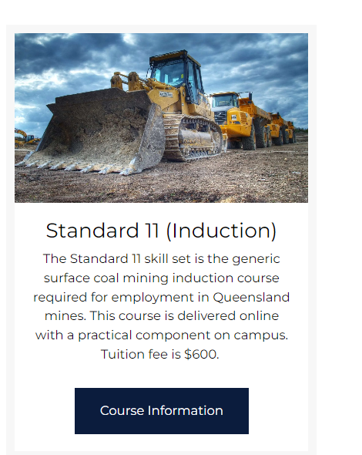

Wording to change to – This course is delivered online. Tuition fee is $600.00

Can we change where the Enrol Now button links to. Instead of that course table, can this button link to:

https://web.powerprorto.com.au/vidatek/wp/enrol/form/66/miningskillsaus

Wording changed:

Delivery Method: Online with workplace verification on site

Update course requirements to be:

* Be 18 years or older
* Have sound language and literacy skills
* Have basic computer skills
* Access to a mining workplace